CHMG-141 GENERAL & ANALYTICAL CHEMISTRY I
With Dr. Bailey
Name: ______________________

Recitation
Week 2
Key Skills:

- Working with atomic numbers, mass numbers, and Isotope symbols
- Calculating atomic weight
- Converting between Moles and numbers of atoms
- Converting between mass and amount (in Moles)
- Nuclear reactions

1). Working with the Periodic table:

- Name the third-period noble gas

- Name the 5-th period alkaline earth metal

- Name the third-period halogen

the second –period halogen

2). Which of the following pairs of elements do you expect to be most similar? Why?

- N and Ni
- Mo and Sn
- Na and Mg
- Cl and F
- Si and P

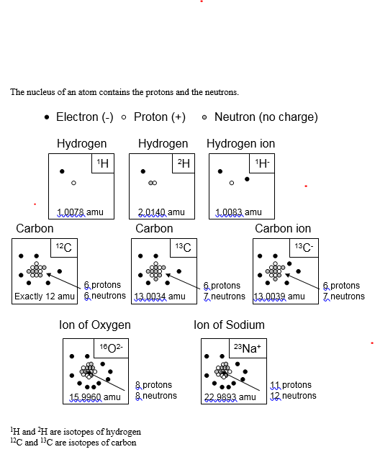

3). What element is defined by the following information?
a) p+ = 50, n° = 20, e- = 50
b) p+ = 13, n° = 14, e- = 10

4). Write symbols for the following isotopes:
a) Polonium-210
b) Z = 27 and A = 60

5) Given the following nuclear notations:
₉F¹⁹ ₃₂Ge⁷³ ₉F¹⁸ ₂₇Co⁵⁹ ₄₄Nb⁹³

- Which one has 32 protons?
- Which one has the same number of neutrons as it has protons?
- Which one has an incorrect atomic number?
- Which two are isotopes?
- Which one has 41 neutrons?

6). Rubidium has two naturally occurring isotopes with the following masses and natural abundance:

Isotope Mass (amu) Abundance
Rb-85 84.9118 72.15
Rb-87 86.9092 27.85

Calculate the atomic weight of rubidium

7). Calculate:

- How many moles of nickel are in 44.03 grams?

- What is the mass of 9.041X10²⁴ lithium atoms?

- How many grams of Ca are in 4.55 moles?

- 27.92 grams of iron are how many atoms of iron?

- There are how many moles are in 18.0X10²¹ atoms of Pt?

Problem 8: You have a piece of copper that is 9.36 cm long, 7.23 cm wide and 0.95 mm thick. Density of copper is 9.00 g/cm³
How many atoms of copper are in this piece of copper?

The strategy:

- Find mass of the piece of copper (dimensions→volume→mass)
- Find how many moles of copper are in this sample
- Find how many atoms of copper are in this sample

Problem 9: Recently, there has been concern about pollution in the home from radon, a radioactive gas whose elemental molar mass is 222 g/mol. The Environmental Protection Agency believes that a level of radon of 3.6x10⁻¹⁷ g/L of air is unhealthy. At this level,
- How many moles of radon would there be in a living room whose volume is
2455 L?
- How many atoms is this?

Problem 10:
